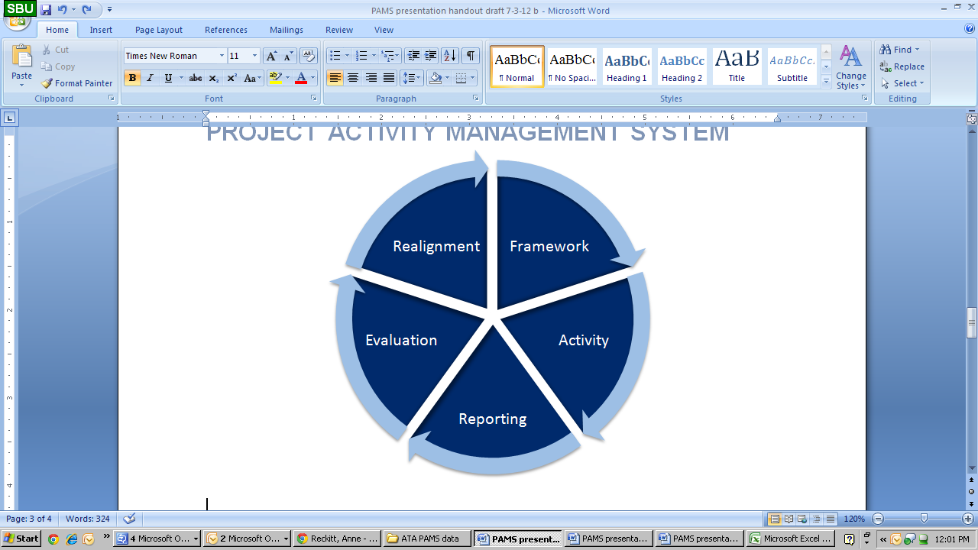The Project Activity Management System (PAMS) is a web-based tool that enables those working in the CT Bureau to manage, track, and streamline their project activities by coordinating with colleagues from the proposal stage to implementation. The PAMS system enables transparency within the Bureau and produces easily accessible reports, housing all information in one organized place.

PAMS site: [www.ctprograms.com](http://www.ctprograms.com)

For a user log-in, please email ctpamshelp1@state.gov.

**When logging into PAMS, you are given access to a range of tools:**

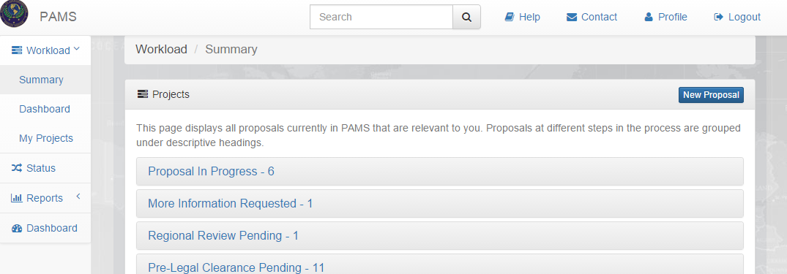

* **Workload Summary:** If a user has tasks to accomplish, this tab lists all items that require an action from the user, which can be completed by clicking on the item. Users in certain roles can also enter new proposals into PAMS.
* **Status:** This tab allows users to see exactly where each proposal is in the approvals process
* **Reports:** A range of reporting methods is available within PAMS.
* **Search box:** This box at the top of every page allows for easy searching within the system.
* **Help:** Process diagrams, contact information for support and more.

**Reporting:** PAMS offers a robust reporting interface which allows users to view reports that are generated against activity data that have been entered into the system.

* Activity Reporting – upload AARs, Success Stories, etc
* Filterable matrix
* Exportable tables, charts, and graphs
* Interactive Funding Map
* Excel sheets formatted with customizable fields